Helpdesk – Cause & Action Taken Close Codes

Contents

Purpose 1

Causes 1

Enabling Ticket Causes 1

Creating Ticket Causes 2

Actions Taken 3

Creating Action Taken 3

Using Ticket Cause & Action Taken 4

# Purpose

The purpose of this document is to describe how the Causes and Actions Taken enhancement will be used in the Odoo Helpdesk module. Causes and Actions Taken fields are added to the ticket and are used to easily describe what the cause of the ticket was and what action was taken to resolve the ticket. The fields can be controlled and used in reporting. Depending on the Ticket Type, the users will select a cause and action taken during the resolution stage of the ticket. These fields can then be used for reporting to find common or trending scenarios.

# Causes

Causes are used to describe the reason the ticket was created. What caused the issue that resulted in the ticket being created. Causes are based on the Ticket Type and can be configured to not be used for certain ticket types.

## Enabling Ticket Causes

Each Ticket Type can have Causes and Actions Taken enabled. When the Ticket Type does not have the Cause/Actions enabled, those fields are not visible and not required on the Ticket.

Note: Only users with ‘Manager’ permissions can manage Ticket Types

To enable Cause/Actions…

1. Go to **Configuration**
2. Open **Ticket Types**
3. Check the **Enable Cause/Actions** box for each Ticket Type that will use require them.

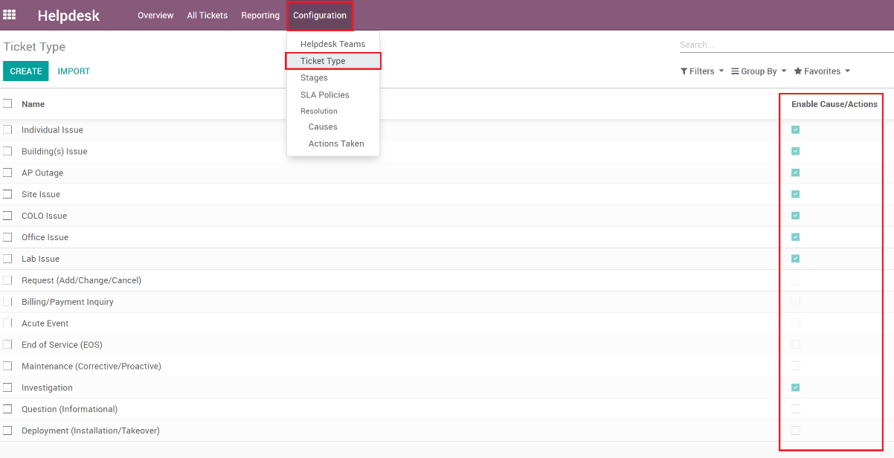

## Creating Ticket Causes

Once the Ticket Type is enabled to use Causes and Actions Taken, the user with ‘Manager’ permissions can now create Causes.

1. Go to **Configuration**
2. Then open **Causes**
3. Click the **Create** button

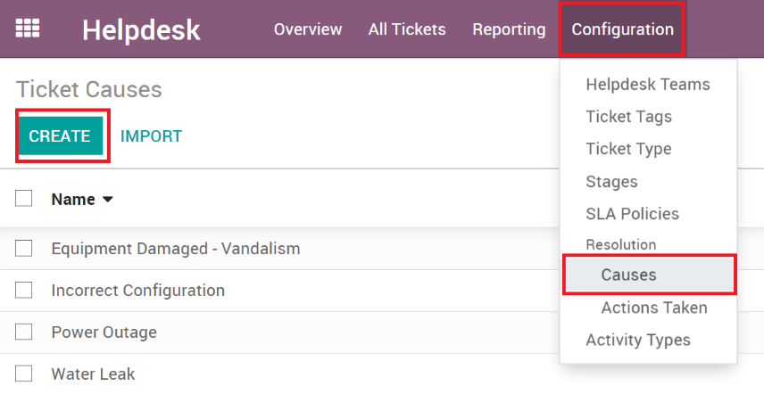

1. Enter the required information
   1. **Name**: The name of the Cause, this will show on the field when the user selects it.
   2. **Ticket Types**: This Cause record will show for all the Ticket Types that are chosen.
   3. **Description**: Provides a helpful description for users to understand the meaning of Cause.

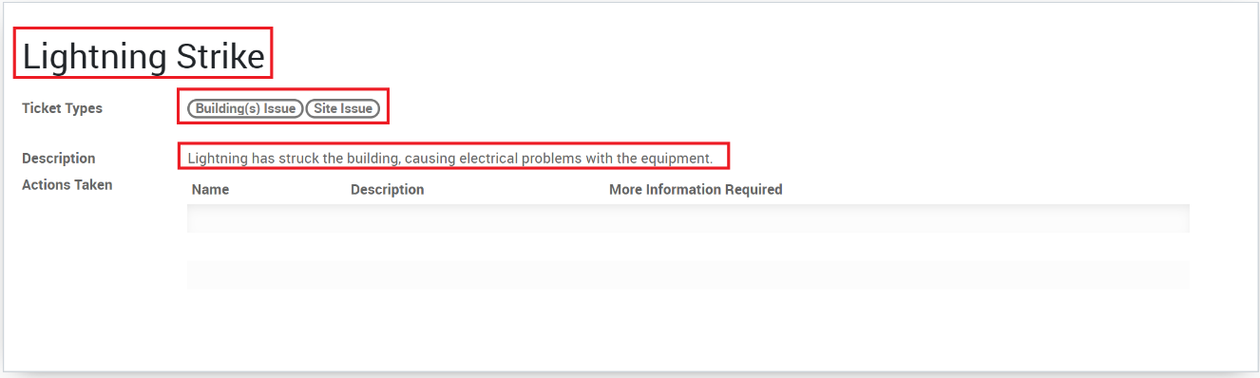

1. *Optional*: You can select existing Actions Taken here or create new ones. See ‘Creating Actions Taken’ below for more information.
2. Click **Save**

# Actions Taken

Actions Taken are used to describe what action was taken to resolve the ticket. Actions Taken records are linked to the Cause, therefore the list of actions that show are only ones related to the selected Cause.

## Creating Action Taken

Creating Actions Taken items is like creating Causes.

1. Got to **Configuration**
2. Then open **Actions Taken**
3. Click the **Create** button

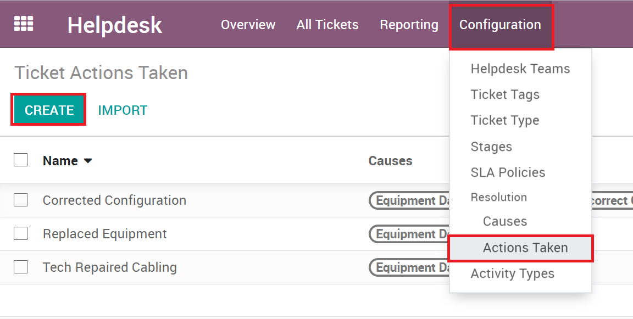

1. Enter the required information
   1. **Name**: The name of the Action Taken, this will show on the field when the user selects it.
   2. **Causes**: The Action Taken record can show for one or more causes.
   3. **More Information Required**: When set, whenever a user selects this Action Taken, another field will be shown and required for the user to add additional information regarding this action.
   4. **Description**: Provides a helpful description for users to understand the meaning of the Action Taken.

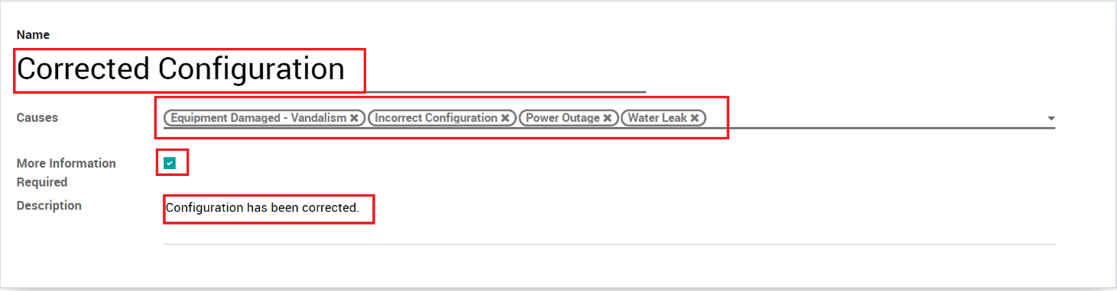

1. Click **Save**

# Using Ticket Cause & Action Taken

Now that Causes and Actions Taken records have been created. The user will now see them on the Tickets.

1. When the user has selected a Ticket Type that has Cause/Actions enabled, they will see the Cause and Action Taken fields.
2. During the resolution process of the ticket, the user will enter the Cause. These will be filtered based on the Ticket Type that is selected.

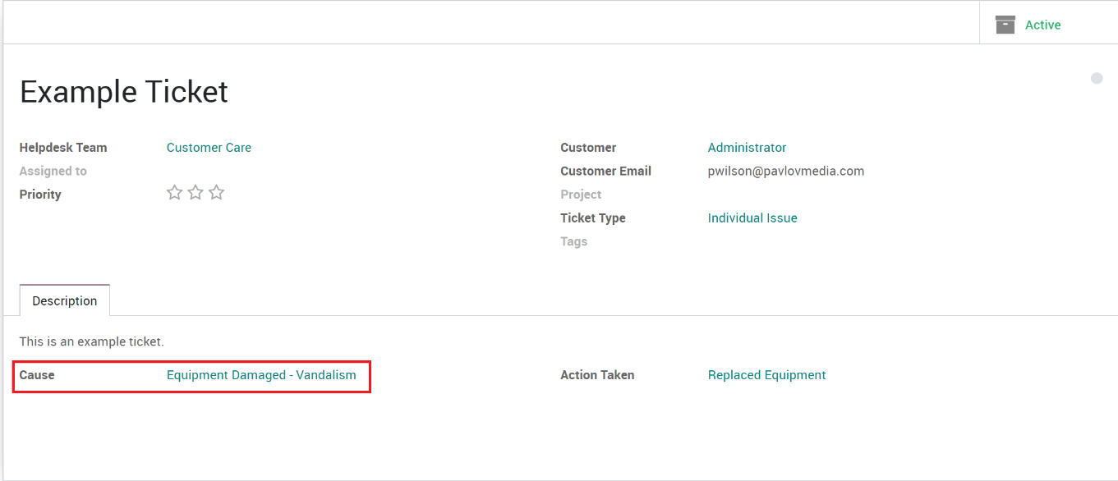

1. The user will then select the Action Taken, which is filtered by the Cause they have selected.

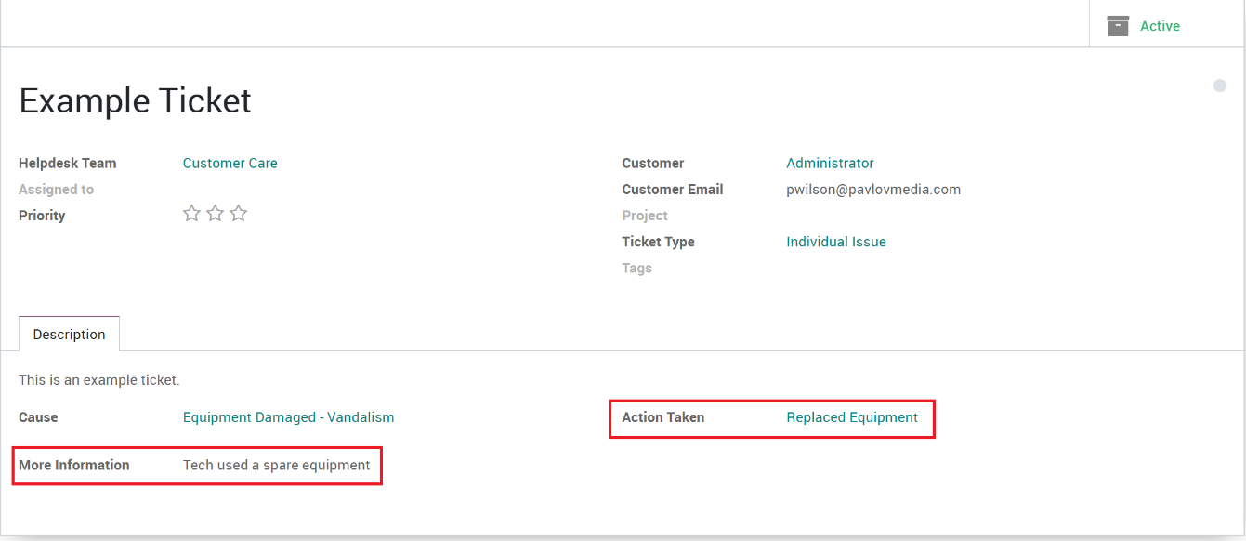

1. If the Action is set to require more information, the user will see an additional field called More Information and they will have to enter additional information for this action.